What is coaching?

Coaching is a way of interacting and ‚being’ with other people. It is dynamic and interactive process that enables and enhances the performance of the other. The process involves conversation through questioning, listening and a range of other interpersonal communications. Your coach will not tell, advise or guide you. Your coach will enable you to discover appropriate solutions from within. It allows the individual to see and explore new perspectives. It creates insight and self-awareness. It brings together thoughts and emotions and enables decisions and choices.

There are many misconceptions about coaching.

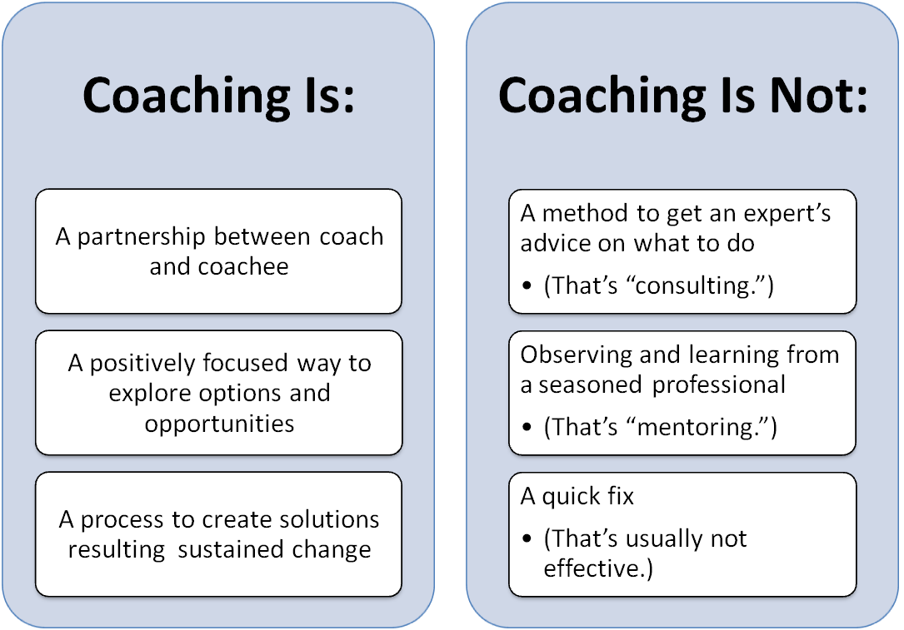

Source: le Blanc, Lilian J., 2014, Creating Great Leaders through Coaching, www.greatplacetowork.com

How does the coaching process work?

The coach asks questions, focusing the coachee’s attention. It is then remarkable to discover what lies within. There may be answers that have been there all the time but have remained dormant for days, weeks, months, years – even decades. Such is the potential of coaching. This is why it is such an exciting form of learning and development.

In coaching you start wherever you are. A single question that encourages the other person to think can be described as a coaching question.

And remember that coaching is client-led.

What should a coachee do in the first meeting?

- Think about a pre coaching questionnaire. Find out if the coach is the right one by building up rapport with the coach by asking 5 questions you would like to know about the coach.
- Think of the answers for the same questions yourself. Please remember not to look for answers anywhere and not to spend much time on each question.

Some sample questions are given below.

- What are the 3 biggest changes you want to make in your life over the next 5 years?
- If anything was possible what would you wish for?
- What is most important to you in your life and why?
- Is your life one of your choosing? If not who is choosing it for you?
- On a scale of 1 -10 how happy are you with your life right now? What are the things that make you happy?
- On a scale of 1-10 how motivated are you in your work/personal life? What motivates you?
- On a scale of 1 -10 how stressed do you feel right now – what are your key stressors?
- List 5 things that you feel you are ‘putting up with’ right now?
- What would you like your coach to do if you struggle with your goals?
- How will you know when you are receiving value from the coaching process?
- What approaches motivate /demotivate you?
Source: www.personal-coaching-information.com

Before first session

1 Be prepared

This is such an obvious point but often ignored. Many coachees appear at the coaching session having been flat out at work. They are under pressure, flustered and totally unprepared. Everyone can find five minutes to think about what comes next. And it is more productive to delay the start and shorten the session but enter into it prepared, rather than to rush straight into the session. The tick list is straightforward:
- What do I want to get out of this session?
- What is my key point for discussion and working on?
- What happened last time, what were the conclusions? What did I learn?
- How important is the issue I want to discuss?
- How do I feel about it?
- How much effort am I prepared to put in to get it resolved?
- Are there any related issues?
- What are the one or two other areas I want to explore if there is time?

Jot down a few notes and take them into the session.

2 Rehearse
How will you explain the issue in hand? You need to run it over in your mind so that when the session begins, you will have clearly enunciated what the issue is. So many coaching sessions go wrong or take ages to focus because there is no clarity between what the client means and what the coach understands.

3 Set outcomes
Your coach should always ask you what you want to get out of the session, but that should not stop you from running over in your own mind what would success look like and feel like. Be clear about outcomes.

4 Be clear about what you want to change
Is the resolution dependent on a lot of action on your part or simply in airing the issues? Be clear if you want something to happen and own any actions you agree to take.

5 Concentrate
Concentration is a key to success. Try not to get distracted - don’t answer your phone or glimpse at incoming emails and texts. For the time that you are in the session, give it your full and undivided attention.

6 Seek clarity
Do not proceed when you are not clear what is being said or even agreed. Rehearse the main points out loud. "So my feeling is that the best course of action would be . . ."

7 Take time to reflect
It is fine to ask for a minute to go over that last point or to think through something. If it is about a conversation, for example, go over it in your own mind quietly whilst the coach is there and raise any concerns immediately.

8 Don't hide your feelings
Be honest about how "hard" something is, or how that made you feel. Say when you feel a real sense of direction emerging out of the session, or that what you have agreed to do will be very stressful and demand a lot. Avoid pretending that everything is fine, when it clearly isn’t.

9 Be honest
Always have the courage to be totally honest as this is one place where you can admit to failure, frustration or even despair. Get used to being frank and unambiguous and to giving honest feedback. It will help the sessions go really well.

10 Get the most out of it that you can
Finally, remember that you are really fortunate to have this time set aside to focus on what you need and to help you do your job better. The vast majority of people do not get that opportunity and can be struggling as a result. Therefore, treat each session as a huge event that you are determined to get the best out of, not as a bit of a chore to be got through.
Paine, Nigel, 2011, How to be a good coachee, www.trainingzone.co.uk

Thank You!
Your Coach

